Please Help me finish this Calendar
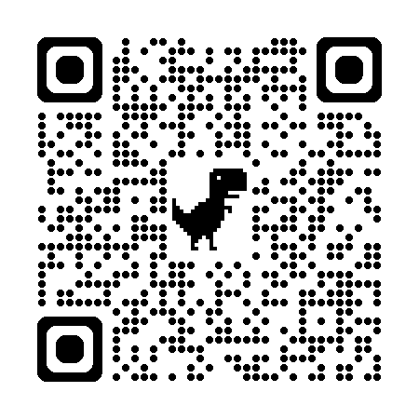
I have created a web app to help residents find out what is happening at McAllen Mobile Home Park

Try it from
your phone
and PC.

Please use the QR Code to navigate to the site and test it.
Click on everything and see if it works for you.
THIS IS A DRAFT SITE: known issues:
- Some links don’t work
- The dates and times are wrong (I am working on getting an uncorrupted list of dates and times. If you know what activities (card games – bingo – exercise class) are still happening during summer, please contact me so I can fix the summer schedule.
Some Questions you can answer for me:
- Do you understand what this site is for?
- How to use it? Etc…
- Is it obvious what all the buttons do?
- Could you figure out how to do what you needed/wanted to do?
- Is there anything not working?
- Is there anything that “should” be added.
- Is there anything that does not need to be there?
There are no wrong answers. Please have fun and then:
Send me an email with your feedback using the Contact Event Coordinator button on the site.
THANK YOU FOR YOUR HELP
John Barkle (495 Grapefruit)

